CSCE 582 Spring 2009

Test 1

2009-02-18
Closed book and notes

Consider the following simple Bayesian network. The network describes a situation in which a bell rings if and only if either one of two fair coins turns up heads.



(1—10 points) Fill the d-separation column in the table below.

Variables | d-separated? | independent?
Heads1?, Bell_Rings? | No | No
Heads2?, Bell_Rings? | No | No
Heads1?, Heads2? | Yes | Yes
Heads1?, Heads2? given Bell_Rings? | No | No

(2—10 points Compute the joint probability P(Heads1?, Heads2?, Bell_Rings?) by filling in the following table. The first entry is given to you.
Heads1? | Heads2? | Bell_Rings? | P(Heads1?, Heads2?, Bell_Rings?)
F | F | F | 0.5*0.5*1 = 0.25
F | F | T | 0.5*0.5*0 = 0
F | T | F | 0.5*0.5*0 = 0
F | T | T | 0.5*0.5*1 = 0.25
T | F | F | 0.5*0.5*0 = 0
T | F | T | 0.5*0.5*1 = 0.25
T | T | F | 0.5*0.5*0 = 0
T | T | T | 0.5*0.5*1 = 0.25

(3—10 points) Use the table above to determine whether Heads1? is independent of Heads2? given Bell_Rings?. Complete the independence column in the table on the first page.
Now consider the following Bayesian network, which has the same variables as the previous one.

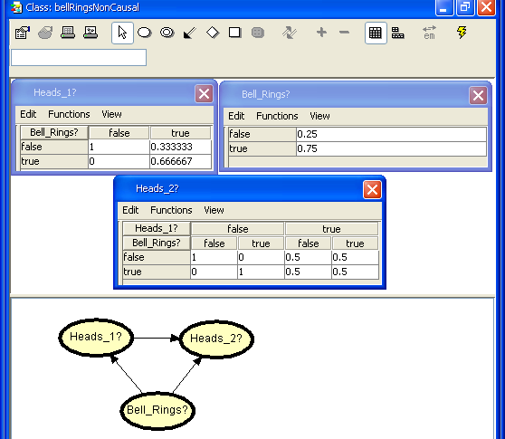

(4—10 points) Fill the d-separation column in the table below.

Variables | d-separated? | independent?
Heads1?, Bell_Rings? | No | No
Heads2?, Bell_Rings? | No | No
Heads1?, Heads2? | No | Yes
Heads1?, Heads2? given Bell_Rings? | No | No

(5—10 points Compute the joint probability P(Heads1?, Heads2?, Bell_Rings?) by filling in the following table. The first entry is given to you.
Heads1? | Heads2? | Bell_Rings? | P(Heads1?, Heads2?, Bell_Rings?)
F | F | F | 1*1*0.25= 0.25
F | F | T | 0.333*0*0.25 = 0
F | T | F | 1*0*0.25 = 0
F | T | T | 0.333*1 0.75= 0.25
T | F | F | 0*0.5*0.25 = 0
T | F | T | 0.667*0.5*0.75 = 0.25
T | T | F | 0*0.5*.25 = 0
T | T | T | 0.667*0.5*0.75 = 0.25

(6—10 points) Use the table above to determine whether Heads1? is unconditionally independent of Heads2?. Complete the independence column in the table on the first page.

Possible answers for the first question: (1) the joint probability table above is the same as the JPT for part 2, so the same independence relations hold. (2) show that P(Heads1?, Heads2?) = P(Heads1?) * P(Heads2?).
(7—10 points) Here is an example from Greg Cooper via Richard Neapolitan. Suppose that metastatic cancer is a cause of brain tumor and can also cause an increase in total serum calcium. Suppose further that either a brain tumor or an increase in total serum calcium could cause a patient to fall into a coma, and that a brain tumor could cause papilledema.

Draw a causal network representing the example. Use only the following five binary variables: MetastaticCancer (present/not present), SerumCalcium (increased/not increased), BrainTumor (present/not present), Coma (present/not present), Papilledema (present/not present).

Check that in your network SerumCalcium and BrainTumor are d-separated by MetastaticCancer but are d-connected given Coma and any superset of {Coma}. Also check that BrainTumor d-separates Papilledema from the other variables.

Answer:

