CSCE 580 Spring 2014 (First Four Questions)
2014-05-03
Closed book and notes
130 points
All exercises are from the textbook [P]

Question 1 (15 points total)

Consider the graph given below. Let s be the start node and g be the goal node. Let the cost of an arc be its length in the figure. Let Euclidean distance (straight-line distance in the plane) be the heuristic function. For example, the h-value of the node just above and to the right of g is the lowest h-value of all nodes in the graph, except for g itself, even though there is no path between that node and g. In answering the following questions, write names or numbers for the nodes, if you find it convenient. Assume no cycle check.

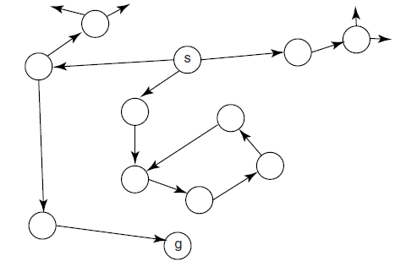
(a) Does heuristic depth-first search terminate on this graph? If so, what is the solution path? If not, why not?
(b) Does best-first search terminate on this graph? If so, what is the solution path? If not, why not?

Answer: p.89 [P]
Question 2 (30 points total)

In the CSP represented by the constraint network below, the three variables (A, B, and C) each have domain {1,2,3,4}.

- List the arcs in the constraint network
- Run the GAC algorithm on this CSP. Show the domains of the variables and the TDA set at each step. Show the domain of each variable at termination.

Answer: pp.121-122 (Examples 4.15 and 4.19) [P]
Question 3 (20 points total)

Consider the abstract constraint graph (a.k.a. interaction graph) in the figure below, with named binary constraints [e.g., r1 is a relation in A and B, which we can write as r1(A,B)]:

Consider solving this network using variable elimination.
- Draw the constraint network corresponding to the interaction graph above.
- Suppose you were to eliminate variable A. Which constraints are removed? A constraint is created on which variables? (Call this constraint r11.)
- Draw the constraint network and the interaction graph after the elimination of variable A.
- Suppose you were subsequently (i.e., after eliminating A) to eliminate B. Which constraints are removed? A constraint is created on which variables?
- Draw the constraint network and the interaction graph after the elimination of variable B.
- Based on your work on parts (d) and (e), briefly comment on the following claim: an interaction graph is less informative than a constraint network.

Answer: Exercise 4.11 (pp.155-156) [P]. For part f, the constraint network would explicitly model the ternary constraint among C, D, and E. The constraint graph does not distinguish the situation in which there is a ternary constraint among C, D, and E from the situation in which there are three binary constraints, with domains {C,D}, {C,E}, and {D,E}.
Question 4 (15 points total)

Consider a CSP that contains the variables A, B, and C, each with domain {1,2,3,4}. Suppose that the (only) two constraints that involve B are given in the tables below:

- Show the steps performed in the elimination of B.
- Show the constraint resulting from eliminating B.

Answer: example 4.24 (p.128) [P].

