Quiz 11 CSCE 580 February 19, 2015

Recall the definition of constraint network for a constraint satisfaction problem (CSP):

* There is a node for each variable of the CSP. These nodes are drawn as ovals.
* There is a node for each constraint. These nodes are drawn as rectangles.
* Associated with each variable, X, is a set DX of possible values. This set of values is initially the domain of the variable.
* For every constraint c, and for every variable X in the scope of c, there is an arc (X, c).

For this quiz, we ignore the domains.

Draw the constraint network for this CSP: There are three variables: A, B, and C. The constraints are A<B and B<C.

**Answer**:



Draw the constraint network for this CSP: There is one variable, X. There is one constraint, X<>4.

**Answer**:

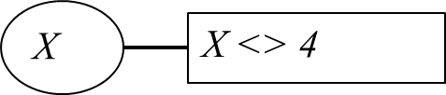

Draw the constraint network for this CSP: There are three variables, X, Y, and Z. There is one constraint, X+Y=Z.

**Answer**:

