CSCE 580 Fall 2011
Fall 2011
2011-12-07
Closed book and notes
All exercises are from the textbook [P]

Question 1 (15 points total)

Consider the graph given below. Let s be the start node and g be the goal node. Let the cost of an arc be its length in the figure. Let Euclidean distance (straight-line distance in the plane) be the heuristic function. For example, the h-value of the node just above and to the right of g is the lowest h-value of all nodes in the graph, except for g itself, even though there is no path between that node and g. In answering the following questions, write names or numbers for the nodes, if you find it convenient. Assume no cycle check.

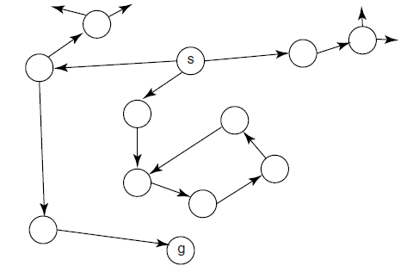
(a) Does heuristic depth-first search terminate on this graph? If so, what is the solution path? If not, why not?
(b) Does best-first search terminate on this graph? If so, what is the solution path? If not, why not?

Answer: p.89 [P]
Question 2 (25 points total)

Let cost_to_goal(n) be the actual cost of a lowest-cost path from node n to a goal; cost_to_goal(n) can be defined as:

Build the cost_to_goal function for the following graph, with r123 as the (only) goal node:

Answer: p. 104 (Example 3.18)
Question 3 (30 points total)

In the CSP represented by the constraint network below, the three variables (A, B, and C) each have domain {1,2,3,4}.

- List the arcs in the constraint network
- Run the GAC algorithm on this CSP. Show the domains of the variables and the TDA set at each step. Show the domain of each variable at termination.

Answer: pp.121-122 (Examples 4.15 and 4.19) [P]
Question 4 (20 points total)

Consider the constraint graph in the figure below, with named binary constraints [e.g., r1 is a relation in A and B, which we can write as r1(A,B)]:

Consider solving this network using variable elimination.
- Suppose you were to eliminate variable A. Which constraints are removed? A constraint is created on which variables? (Call this constraint r11.)
- Suppose you were subsequently (i.e., after eliminating A) to eliminate B. Which constraints are removed? A constraint is created on which variables?

Answer: Exercise 4.11 (pp.155-156) [P].
Question 5 (15 points total)

Consider a CSP that contains the variables A, B, and C, each with domain {1,2,3,4}. Suppose that the (only) two constraints that involve B are given in the tables below:

- Show the constraint resulting from eliminating B.
- Show the steps performed in the elimination of B.

Answer: example 4.24 (p.128) [P].
Question 6 (30 points total)

Consider the following simplistic KB and assumables:

bronchitis <- influenza.
bronchitis <- smokes.
coughing <- bronchitis.
wheezing <- bronchitis.
fever <- influenza.
soreThroat <- influenza.
false <- smokes & nonsmoker.
assumable smokes.
assumable nonsmoker.
assumable influenza.

- Give an interpretation of the KB that is not a model of the KB.
- Give an interpretation of the KB that is a model of the KB.
- What is (are) the minimal explanation(s) if wheezing is observed?
- What is (are) the minimal explanation(s) if wheezing & fever is observed?
- What is (are) the minimal explanation(s) if wheezing and nonsmoker is observed?

Answer: Example 5.30 (p.201) [P]
Question 7 (15 points total)

Consider the following Bayesian network structure. (The probability tables needed to fully specify a Bayesian network are not given and are not needed for this example.)

- Can knowledge of Smoke affect your belief in Tampering?
- Can knowledge of Smoke affect your belief in Tampering given that you have observed a value for Fire?
- Can knowledge of Smoke affect your belief in Tampering given that you have observed a value for Report?
- Can knowledge of Fire affect your belief in Leaving given that you have observed a value for Alarm?
- Which variables could have their probabilities changed if just Report is observed?

Answer: example 6.10 (p.236) [P]

