University of South Carolina Chapter of

Presents
Autonomous Vehicles:
When Will Your Car Drive You?
The UPE Keynote Address by
Grayson Randall
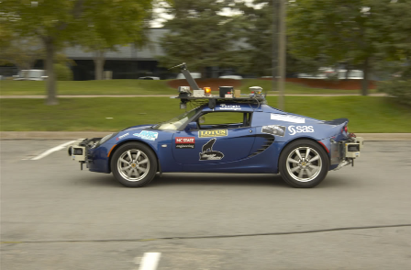
4:00 PM
Thursday, April 23, 2009
Video Conference Center
Room 1A20 Swearingen Engineering Center

Grayson Randall is president of Insight Technologies, Inc., a North Carolina company which specializes in ground based robots for both commercial and military use. Insight Technologies, Inc. performs both research and development for robotic control systems. Mr. Randall led the Insight Racing team in the DARPA (Defense Advanced Research Projects Agency) Grand Challenge series of races and was responsible for the overall system design and architecture of their Grand Challenge entry. Insight Racing’s most recent entry was a computer driven Lotus Elise which was developed in conjunction with NC State University. The Elise would drive through city traffic without a driver, remote control, or any human intervention whatsoever. This work has been featured in the cover story for Machine Design Magazine, on two Discovery Channel programs, and on a BBC special.
Mr. Randall is a “Distinguished Visitor” for the IEEE Computer Society. He received the 2009 Outstanding Engineer Award from IEEE Region 3 for his “contributions to autonomous vehicle design.” Mr. Randall was also recognized by IEEE-USA in 2007 with the Citation of Honor Award “for leadership that inspired pre-college students and college engineering students in the area of robotics.”
Sponsored by: The University of South Carolina Department of Computer Science and Engineering

