2004-2005
Distinguished Lecturers

Jeff Thorne
Statistical Genetics and Bioinformatics
North Carolina State University
November 12, 2004

Kim Boyer
Department of Electrical Engineering
The Ohio State University
November 19, 2004

Dan Reed
Institute for Renaissance Computing
UNC-Chapel Hill, Duke & NC State
January 14, 2005

Jack Dongarra
Department of Computer Science
The University of Tennessee - Knoxville
February 4, 2005

Kang G. Shin
Electrical Engineering and Computer Science
The University of Michigan
February 18, 2005

For details see http://www.cse.sc.edu/~mgv/colloquia/index.html


Computer Science and Engineering

Distinguished Lecture
Series

February 18, 2005

University of South Carolina
Columbia, South Carolina

Professor Kang Shin

Kang G. Shin is the Kevin and Nancy O'Connor Professor of Computer Science and Founding Director of the Real-Time Computing Laboratory in the Department of Electrical Engineering and Computer Science, The University of Michigan, Ann Arbor, Michigan. He received the B.S. degree from Seoul National University, Seoul, Korea in 1970, and both the M.S. and Ph.D. degrees from Cornell University, Ithaca, New York in 1976 and 1978, respectively. He was on the faculty of Rensselaer Polytechnic Institute, Troy, New York, from 1978 to 1982, and has held visiting positions at U.S. Air Force Flight Dynamics Laboratory, AT&T Bell Laboratories, UC Berkeley, IBM T. J. Watson Research Center, Carnegie Mellon University, and HP Research Laboratories. He is Fellow of IEEE and ACM, and member of the Korean Academy of Engineering.

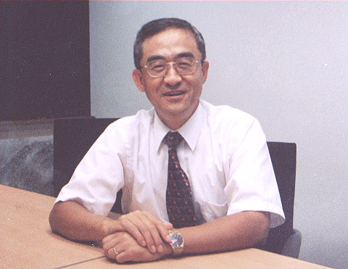

“Management and Application of Sensor Networks”

by

Kang Shin

The University of Michigan

Friday, February 18,
2005

Amoco Hall
Swearingen Engineering Complex (SWGN 1C01)

2:30 pm

Refreshments immediately following
in the lobby area outside Amoco Hall.

Abstract

Under the auspices of DARPA, NSF, ONR and industry, we have been developing middleware for securely managing sensor networks for environment monitoring. This talk will begin with the generic aspects of sensors networks, and then describe details of our current research that covers adaptive query processing (AQP), minimum-cost routing, and security.

Sensor networks, built with thousands of small and smart sensor nodes, may be deployed for various applications, which usually require a certain pre-specified network lifetime. I will first describe a hierarchical architecture for query processing in such sensor networks, and then focus on energy-aware adaptive query processing. Especially, I will present (1) a cost-based query allocation algorithm that minimizes the total power consumption by maximizing cost sharing among different queries; and (2) an energy-aware Quality-of-Service (QoS) adaptation algorithm that gracefully makes tradeoff between total power consumption and total QoS of all queries when node availability or workload changes.

Among many others, efficient routing between sensor nodes and protection sensor nodes and information exchanged between them are essential to support applications like AQP. Hence, the second part of my talk will deal with these two issues.

