2004-2005
Distinguished Lecturers

Jeff Thorne
Statistical Genetics and Bioinformatics
North Carolina State University
November 12, 2004

Kim Boyer
Department of Electrical Engineering
The Ohio State University
November 19, 2004

Dan Reed
Institute for Renaissance Computing
UNC-Chapel Hill, Duke & NC State
January 14, 2005

Jack Dongarra
Department of Computer Science
The University of Tennessee - Knoxville
February 4, 2005

Kang G. Shin
Electrical Engineering and Computer Science
The University of Michigan
February 18, 2005

For details see http://www.cse.sc.edu/~mgv/colloquia/index.html


Computer Science and Engineering

Distinguished Lecture
Series

January 14, 2005

University of South Carolina
Columbia, South Carolina

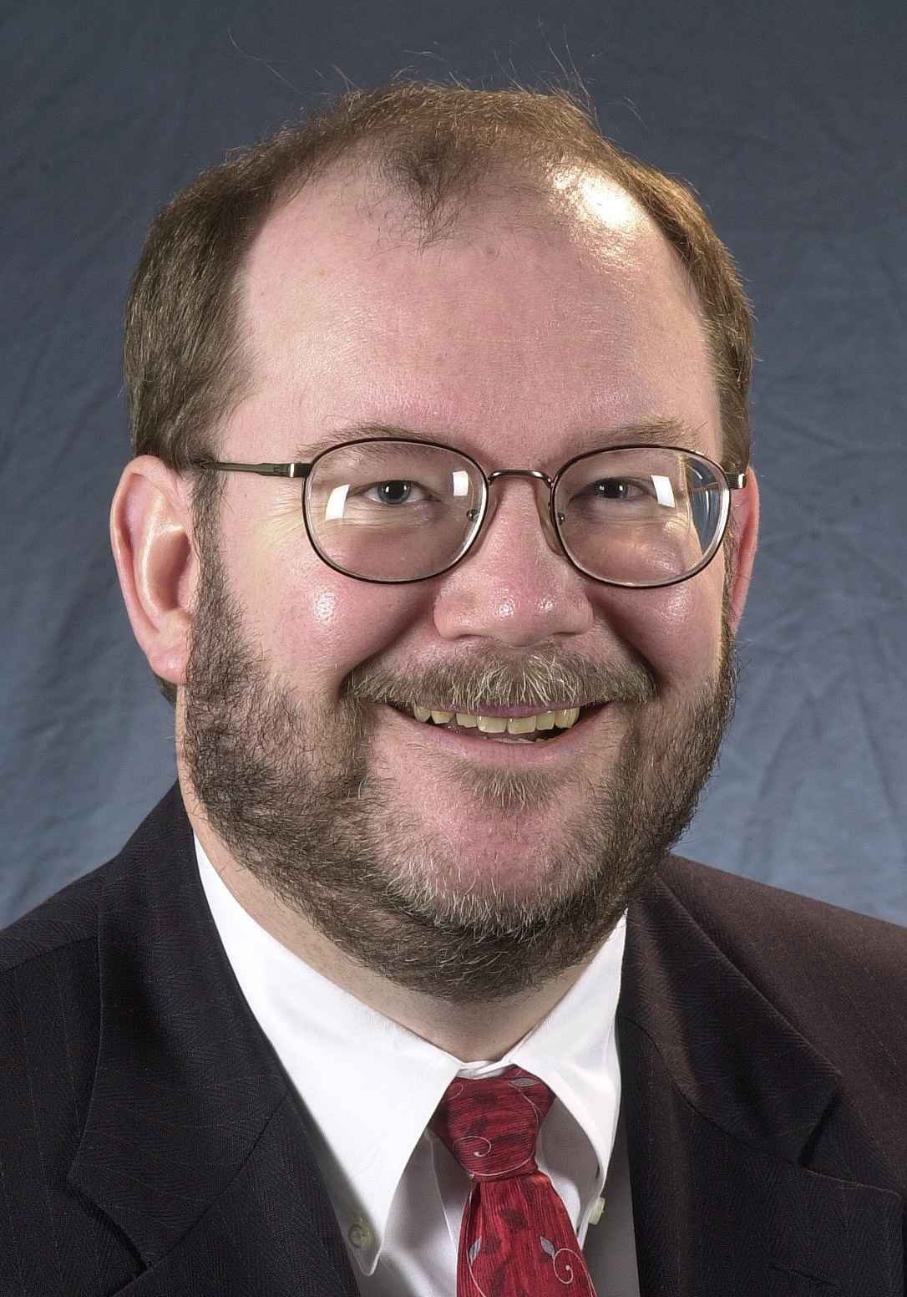

Professor Dan Reed

Dan Reed is the Chancellor’s Eminent Professor at the University of North Carolina at Chapel Hill, as well as the Director of the Renaissance Computing Institute (RENCI), a venture supported by the three universities – the University of North Carolina at Chapel Hill, Duke University and North Carolina State University – that is exploring the interactions of computing technology with the sciences, arts and humanities. Reed also serves as Vice-Chancellor for Information Technology and Chief Information Officer for the University of North Carolina at Chapel Hill.

Dr. Reed is a member of President George W. Bush’s Information Technology Advisory Committee, charged with providing advice on information technology issues and challenges to the President, and he chairs the subcommittee on computational science. He is a board member for the Computing Research Association, which represents the interests of the major academic departments and industrial research laboratories. He was previously Director of the National Center for Supercomputing Applications (NCSA) at the University of Illinois at Urbana-Champaign, where he also led National Computational Science Alliance, a consortium of roughly fifty academic institutions and national laboratories that is developing next-generation software infrastructure of scientific computing. He was also one of the principal investigators and chief architect for the NSF TeraGrid. He received his PhD in computer science in 1983 from Purdue University.

“Computing Challenges: Scalability and Interdisciplinary Applications”

by

Dan Reed

UNC at Chapel Hill
Duke University
NC State University

Friday, January 14,
2005

Amoco Hall
Swearingen Engineering Complex (SWGN 1C01)

2:30 pm

Refreshments immediately following
in the lobby area outside Amoco Hall.

Abstract

Legend says that Archimedes remarked, on the discovery of the lever, “Give me a place to stand, and I can move the world.” As an intellectual lever, computing allows researchers and practitioners to bring to life theoretical models of phenomena when economics or other constraints preclude experimentation. Computing also allows us to capture and analyze the torrent of experimental data being produced by a new generation of scientific instruments and sensors, themselves made possible by advances in computing and microelectronics. Finally, computing, via high-speed networks and distributed collaboration systems, brings people and talent together across the barriers of time and space. Simply put, computing pervades all aspects of science and engineering – “science” and “computational science” have become largely synonymous.

However, we face major challenges. Systems built from commodity processors dominate high-performance computing today, with systems containing thousands of processors now being deployed. Similarly, large-scale Grids containing hundreds of thousands of sites are being contemplated, developed and deployed. As node counts for multi-teraflop systems grow to tens of thousands, with proposed petaflop systems likely to contain hundreds of thousands of nodes, we must rethink traditional assumptions about software scaling and manageability and hardware reliability. This talk will examine a set of interdisciplinary application domains and the implications of those domains for system scalability, fault tolerance and next generation technology.

