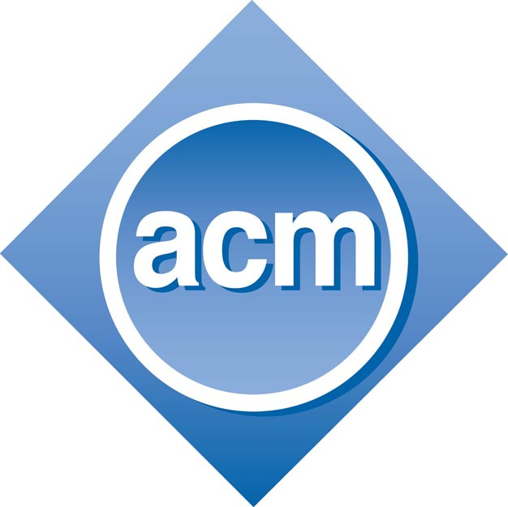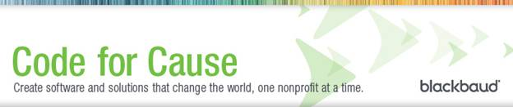

ACM @ USC presents

**Blackbaud**

Wed, Sept 19 @ 6:30pm

2A21 Swearingen

Food and Prizes

**_____________________**

Blackbaud is a for-profit company making non-profit software. Their code is helping to cure cancer, stop hunger, and save the environment.

Come learn about working in software development, Blackbaud, and career opportunities there

www.blackbaud.com/careers

**______________________**