Evaluating Bayesian networks’ precision for detecting students’ learning styles
  - Andrew Smith and Mikhail Simin
Students learn differently according to their varying dimensions of learning styles. In physical classrooms, teachers can recognize and adapt to the styles of their students. This becomes difficult in Web-based courses, where there is no teacher present. The authors propose a student profiling system using Bayesian networks that will predict a student’s learning style based on their study habits, site interactions, and test-taking behavior. Felder classifies students into 5 degrees of learning styles. These styles are divided up into: perception (sensitive or intuitive), input (visual or verbal), organization (inductive or deductive), processing (active or reflective), and understanding (sequential or global). Since most engineering students are inductive learners, this dimension is assumed and is thus eliminated from the Bayesian network.
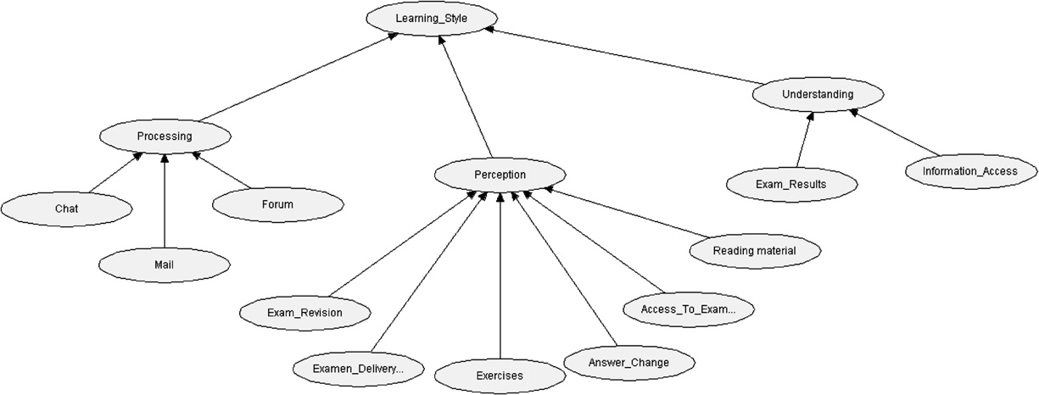
The learning data is acquired from web logs of use of the following: forum, chat, mail, continuity of information access, reading material, exam delivery time, exam review percentage, changes made to previous answers, use of examples, and grades. The leaves of the BN graph are the prior probabilities and all weights were initially assigned to zeros. As the data becomes available from the web logs the weights are adjusted accordingly. The learning function is not provided by the authors. The learning stops when the arrival of new data does not provide a significant contribution to the change of the weights. The threshold value is not provided. The figure above is the authors graph of the intended BN. Critique includes the fact that this network does not describe the student, and is therefore not built as a causal network; the graph presented is more of a data-flow graph. Some nodes are treated as independent data although they are not (i.e. “review of the exam” and “making changes to the answers”).
The experiment was conducted on 27 CSE students in a class of learning AI. Comparing the computation of the constructed BN versus the results of the “expert” test the following percentage of correctness was acquired: perception: 77%, understanding: 63%, processing: 58%. This precision was calculated by
$$Precision=\frac{1}{n}\sum_{i=1}^{n}{Sim(LS_{BN}, LS_{ILS})}$$
where Sim() can take a score of 1, 0.5, or 0 if the dimension is concluded identically, extreme vs neutral, or opposing extremes respectively, by BN versus the expert test ILS (Index of Learning Styles).
In later work, the authors extend their Bayesian learning network to implement an eTeacher system that makes recommendations based on the predicted learning style of the students. The findings of testing this system is illustrated in “eTeacher: Providing personalized assistance to e-learning students," Computers and Education, Computers & Education, Volume 51. They are similar to those presented in this paper.

